Paint Mojo Puerto Vallarta
At Hacienda Mosaico!
With Tracy Verdugo

Supply list

First and foremost let me say that we’re meeting at Hacienda Mosaico to have fun, explore, be inspired and lay some of that inspiration down on paper!

I don’t want there to be any stress about brands or exact supplies. If you came with a sketchbook, a pencil and a packet of felt markers I still think you could have a bunch of fun with the exercises and prompts I have planned for you.

So having said that, here are some suggestions to make the most of six days together.

We will be working mostly with acrylic paints that I will be purchasing in Mexico for the group. If you could bring a tube of titanium white for your personal use that would be great.

So, no need to bring acrylic paints (except for the white)!

Acrylic inks~ My absolute favourite art medium of the moment is the Daler Rowney FW acrylic artist ink range.

Feel free to go crazy with them and bring as many as you like!

They are not super expensive, around $5 a bottle, and a little goes a long way.

My favourite colors are Antelope brown, Paynes grey, Flame orange, Marine blue, Fluorescent pink, Indian yellow, Indigo, Light green, Olive green, Red earth, Turquoise and ALL of the pearlescent colors!

If you haven’t tried them I guarantee you will be addicted by the end of this class!!

If you’re unsure and just want to bring a few you are welcome to try out all of the colors that I will have on hand.

A small cheap watercolour tray to mix colors in will also be good to have on hand.

https://www.dickblick.com/products/daler-rowney-fw-acrylic-water-resistant-artists-ink/

***We will be working on paper, across multiple sheets of all sizes.

My suggestion is to bring the largest size pad you can fit into your luggage. That way you can work on large pieces or cut the paper into smaller sizes.

You can either use a watercolour pad or a mixed media pad.

Something like this would be perfect

https://www.dickblick.com/products/canson-xl-mix-media-pads/

18x24 or 17x14” 60 sheets

If you want a little choice you could also bring a thicker watercolour paper pad to try out like the Strathmore pads below.

https://www.dickblick.com/products/strathmore-400-series-watercolor-paper-pads/

A ruler

A jar of matte medium

A small spray bottle

sketch book for field trips

paint clothes or apron

Stencils (optional-I will have some to share)

Several brushes from fine round to about 1 inch wide flat.

PS any quality will do. The set below from Martha Stewart is only about $20 and they do the job beautifully!

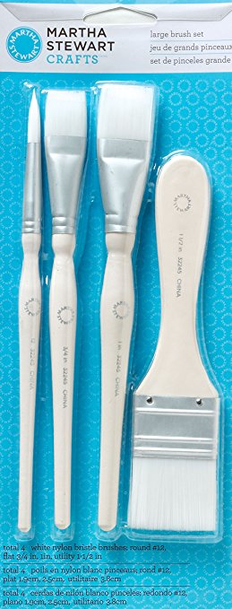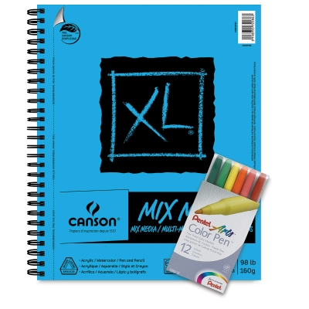

Iphone or camera

Ipad or tablet (optional)

We will be exploring the Historic Central district of Puerto Vallarta and the neighbourhood around Hacienda Mosaico, taking in the colors and exuberant culture, and during these outings I will encourage you via various prompts and exercises to collect images both with your camera AND your sketch book. There will be ample time for those who enjoy sketching on site so please bring whatever you enjoy capturing “out and about” sketches with.

I tend to be quite a simple sketcher, relying mostly on my camera and carrying just a small pencil case with a few lead pencils, watercolour pencils, different colored gel pens, white and black gel pens, a sharpener, a couple of smaller round watercolour brushes and a small plastic bottle of water. A couple of pieces of willow charcoal and a kneadable eraser is also a great addition to your travelling art kit.

***If you enjoy travelling with a small watercolour kit by all means bring it but it is completely optional.

That’s all for now

See you in Puerto Vallarta!

Tracy <3

